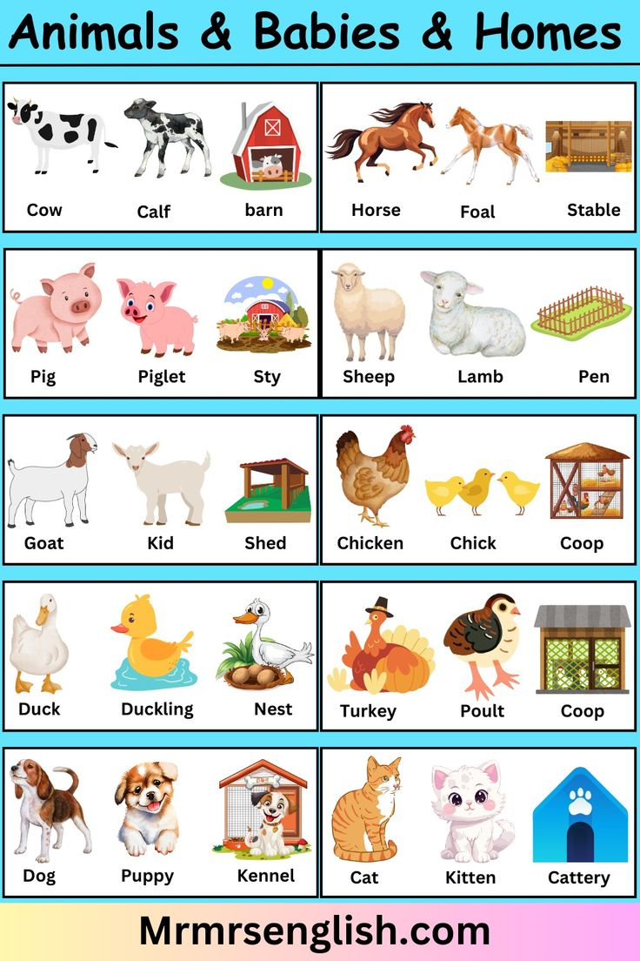
COW AND ITS YOUNG ONE IMAGE

